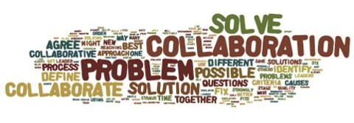
You are invited:

To an evening of community collaboration—

EXPLORING OUR ENHANCED REPORT CARD

As you know, SD43 has designed a standard report card for communicating student learning which more closely supports the redesigned BC curriculum. Parents in the Northside community of schools are invited to come and see the report card and participate in a dialogue about changes to the template.

When: 6:30—7:30 Wednesday, November 15, 2017
Where: Kwayhquitlum Middle School, Library
3280 Flint Street
Port Coquitlam, BC

